EXERCISE 9
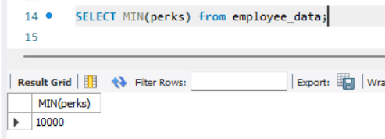
- List the minimum perks package.

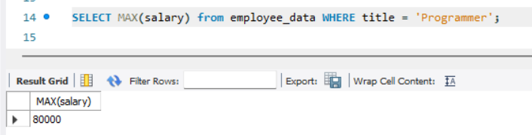
- List the maximum salary given to a “Programmer”.

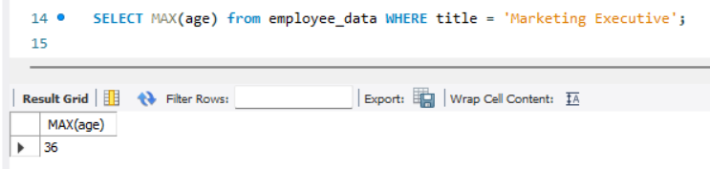
- Display the age of the oldest “Marketing Executive”.

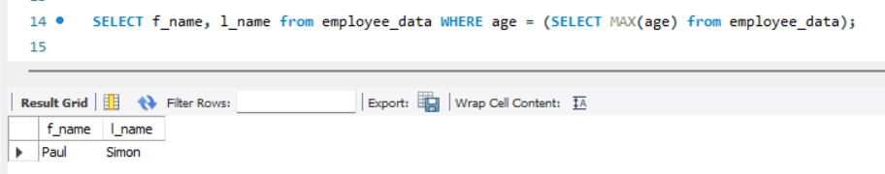
- (Tricky!) Find the first and last names of the oldest employee.

